|  |  |
| --- | --- |
| A picture of a winding road and trees  idc30bt sELF- EVALUATION REPORT  ON-CAMPUS TAINING | Surname: Mokoena  Initials : KA  StudentNO: 214810948    JULY-DECEMBER 2018 |

Table of Contents

**Introduction1**

**Preparation for Expo2**

**Training on HTML and PHP3**

**Develop Transy Website PHP and HTML 4**

**Training on PHP MVC5**

**Develop Transy Website6**

**Training on GitHub…………………………....………………………………………………………………….7**

**Training on Android Studio………………………………………………………………………………………8**

**Develop Transy Mobile App……………………………………………………...……………………9**

***Introduction***

Throughout the course of my training I was given an opportunity to use an open source

DBMS to create tables, relationships and users, assign rights to users on database for the

system that we were tasked to create (TRANSY). I got experience to apply a suitable test

methodology to design test data for the system.

***Preparation for Expo***

I have learned how to work with a number of individuals in our group. I have benefited from

cooperative learning, and it has enhanced the total output of the activities that we were doing

on a daily basis than I’d do individually. We have learnt more about the audience and Ngwete

IT Solutions whom we were supposed to present our system to. I was resposible for creating “become a driver: page. We have practiced on how

we’d define our objectives of the system and the body of our presentation, we have also

practiced on selling our system to Ngwete IT Solutions, which is the company and further

addressed how our system works, with that being said we have came second and have also

won certificates for each member of our group, caps, etc.

**Become a driver**

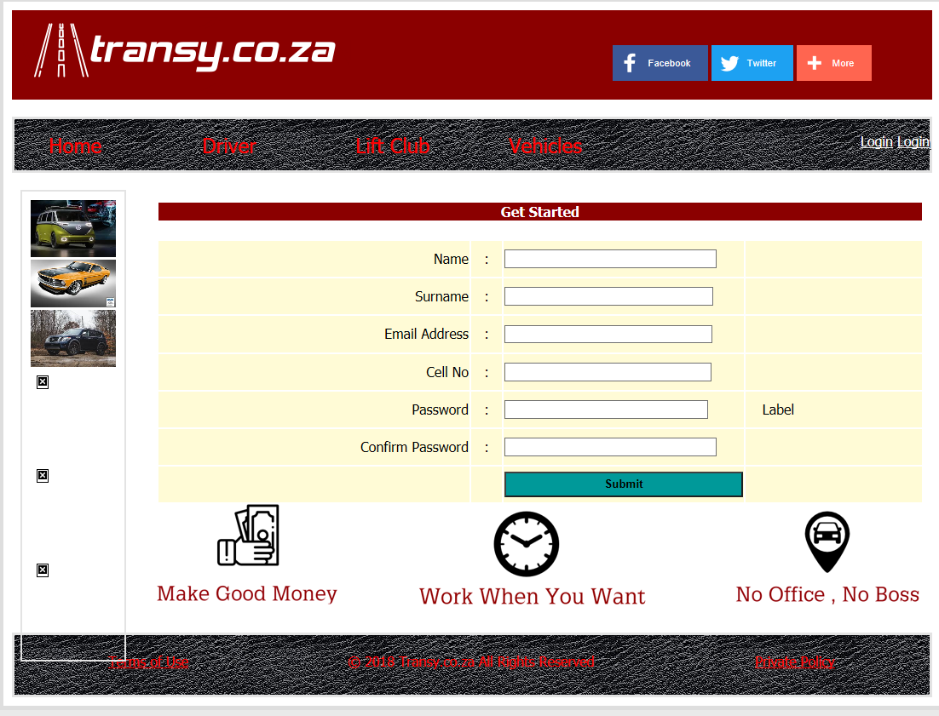

***Training on HTML and PHP***

Hypertext Markup Language(HTML) is the standard markup language for creating web pages

and web applications. PHP is the most popular scripting language on the web, without PHP

applications like facebook, Yahoo, Google wouldn’t exist so I have learned that PHP is the

core scripting language for most applications to work. We have made use of PHP and HTML

forms to build our projects. We have used suitable strategies to ensure integrity of data and

we have also used suitable strategies to handle page database and other errors. I have

learned that PHP scripts can only be interpreted on a server that has a PHP installed. The

client computers accessing the PHP scripts require a web browser only. I have also learned

that a PHP file contains PHP tags and ends with extension “.php”.I have also learned the

difference between scripting language and programming language, the PHP syntax, what

PHP is used for and PHP file extensions.

***Develop Transy Website PHP and HTML***

I was responsible for creating the database and populating it with information that the

system might need together with some of the group members. Although I had challenges

with not coming to school every day because of family issues but I managed to

communicate with the group leader and had some of the work done at home, such as

designing the use case diagrams, entity relationship diagram, sequence diagrams, package

diagrams, etc. we have encountered challenges as a group along the way but we have

managed to resolve some of the problems and sometimes our system would crush and take

us back to square one but we still managed to get some of the work done .I was responsible for creating update link to enable a driver to update his/her details. Before some

evaluations we would still meet certain requirements.

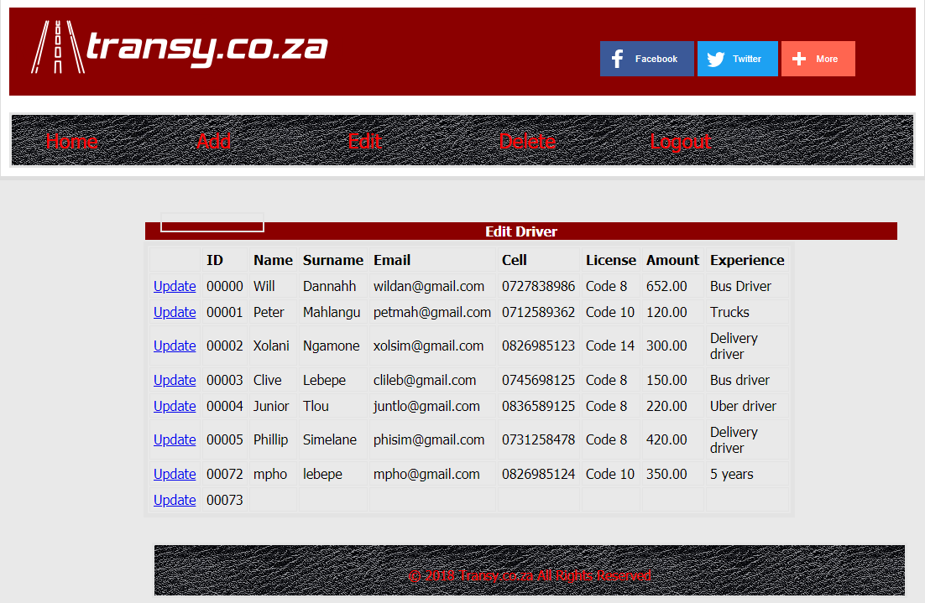

***Training on PHP MVC***

I have learned a lot on PHP MVC and I think this has added to my advantage further into my

career, as I can differentiate pages on Model, View and Controller. I have learned about how

MVC framework works, I can also create my own MVC framework and create a simple CMS

based on the framework that was created. I have mastered in creating MVC web

application, further the result of application developing during this training has put into

good practice. As a consequence, I have created a light-weight framework and CMS which

has been used in our project. It contains pages view and editing, form, admin section and

authorization. During this training I have learnt the best practices in PHP OOP, sessions and

MySQL interactions.

***Develop Transy Website***

Developing the Transy website has been very much productive, in terms of learning new

things about websites. I learned that creating a website needs a lot of time, focus and

positive attitudes in order to satisfy the targeted clients. The clients have to like the website

from the word go and develop interest in going forward to viewing the existing pages that

our website has to deliver. Catching the client’s eye with the home page of the system was

one of our main goal into creating our website.

***Training on GitHub***

GitHub is so much easier in terms of uploading our work and it is user friendly. It doesn’t

take much time uploading and it lets us go back and view the work that we have uploaded

as well as downloading again for editing purposes.

***Training on Android Studio***

This training on Android studio has been an eye opener in so many ways, it has made me

realise and also know of many other mobile softwares. We have been taught of the android

Operating System, how to create the mobile app (ANDROID) and many other coding.

***Develop Transy Mobile App***

During the development of Transy Mobile App, one of our group member left and our group

had differences on who has to do the work, which resulted into us parting ways, there were

only two members left in our group, including me but we still managed to get the work done

on submission day. We were tasked to create a mobile app that has a home page, about

page, that lets a user register his/her details, user login to the mobile app and validation.